PUMPKIN GINGER CUPCAKES

Ingredients:
- 1 1/2 cups all purpose flour
- 1 teaspoon baking powder
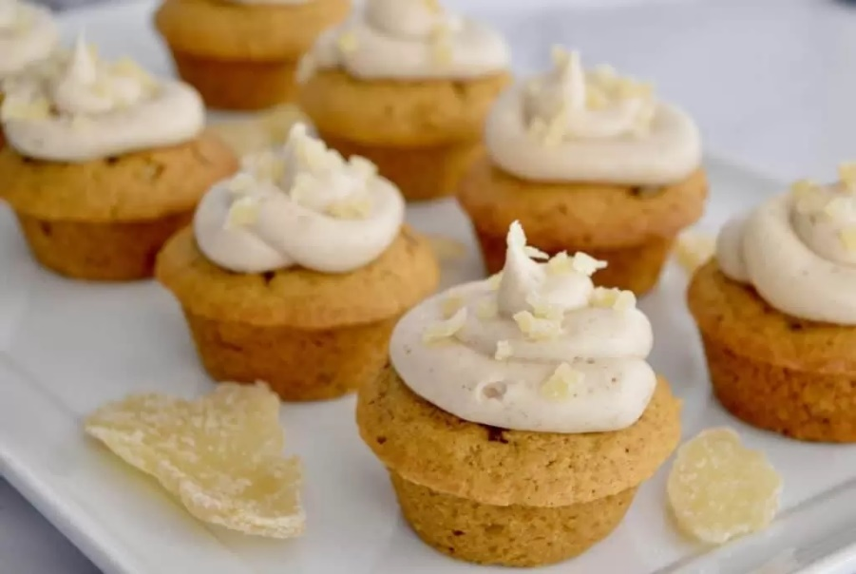
- 1/2 teaspoon baking soda
- 2 teaspoons ground cinnamon
- 1/2 teaspoon ground ginger
- 1/2 teaspoon salt
- 1/2 cup unsalted butter, softened
- 1 cup sugar
- 2 large eggs
- 3/4 cup canned pumpkin
- 1 teaspoon vanilla
- 1/4 cup diced crystalized ginger (like Paradise)
Cinnamon Ginger Cream Cheese Frosting
- 4 ounces cream cheese, softened
- 1/4 cup unsalted butter, softened
- 1 1/2 cup powdered sugar
- 1/2 teaspoon vanilla
- 1/2 teaspoon ground cinnamon
- 1/4 teaspoon ground ginger
Topping
- 1 tablespoon diced crystalized ginger (like Paradise)

Directions:

Pumpkin-Ginger Cupcakes
Preheat oven to 350 degrees. Grease 12 muffin cups or line with paper liners, set aside.
In a medium bowl, whisk together the flour, baking powder, baking soda, cinnamon, ginger, and salt. Set aside.
In a large bowl, beat butter and sugar with an electric mixer at medium speed until light and fluffy, about 2 minutes. Add eggs, canned pumpkin, and vanilla and beat well. Add in flour mixture and beat on low until just incorporated. Fold in 1/4 cup of diced candied ginger.

Pour the batter into the prepared muffin tins (a muffin scoop helps here). Bake until golden, and a toothpick inserted in the middle of the cupcake comes out clean, about 24-27 minutes. Let cool in pans 10 minutes, then transfer cupcakes to a wire rack to cool completely.

Cinnamon Ginger Cream Cheese Frosting
Use an electric mixer to beat together cream cheese and butter in a medium bowl for about 2 minutes. Add in the powdered sugar, vanilla, cinnamon, and ginger and beat until well combined. Spread frosting over cupcakes using a butter knife, or pipe on using a piping bag. Sprinkle on remaining diced candied ginger.

Notes
Make ahead the cupcakes and freeze for up to a month in an airtight container. Defrost, then add the frosting before serving. Alternatively, you can make the entire cupcake up to 2 days in advance and store in an airtight container in the refrigerator until ready to serve.

