Overnight Slow Cooker
French Toast Casserole
Start this slow cooker breakfast before bed on Christmas Eve or before the weekend, then wake up to fantastic smells and a meal that’s ready to serve. Gifted a panettone this year? Use it here, if desired.

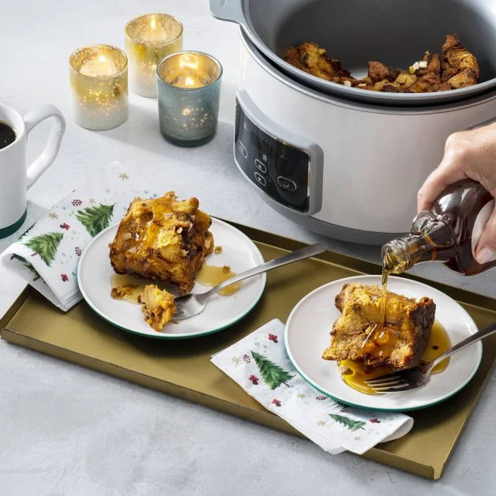
Ingredients:

- 24 oz challah bread, brioche bread, or panettone (about 1 ½ loaves)
- 8 large eggs
- 4 cups whole milk
- 3 tbsp packed brown sugar
- 1 tbsp vanilla extract
- 1 1/2 tbsp ground cinnamon
- 1/2 tsp salt
- 1 tbsp unsalted butter, softened
- 1/4 cup Paradise ® Candied Orange Peel
- 2 tbsp chopped Paradise ® Crystallized Ginger
- Maple syrup, for serving

Directions:
Preheat oven to 300°F. Using a serrated knife, cut the bread into ¾-inch cubes (about 15 cups). On two large rimmed baking sheets, spread the bread cubes in a single layer. Toast 20 min., stirring halfway through, until dry and golden. Let cool 10 min.
Meanwhile, in a medium bowl, whisk the eggs until smooth. Add the milk, brown sugar, vanilla, cinnamon, and salt. Whisk to combine.
Grease a 6-qt slow cooker bowl with the butter. Add the bread cubes, candied orange peel, and crystallized ginger to the slow cooker and arrange in an even layer. Pour the egg mixture over top, gently pressing on bread cubes. Let soak 15 min., then carefully stir without touching sides. Gently press bread cubes into liquid to pack down in an even layer.
Cover and cook on low 7–8 hours until custard is set and puffy. Let rest 15 min. Serve warm with the maple syrup

Tips:
To make this recipe quicker, cook on high 3–4 hours.

