Chocolate-Cherry Babka
Perfect for holiday gifting or a festive brunch, this homemade chocolate-cherry babka comes together in a fraction of the time thanks to crescent roll.
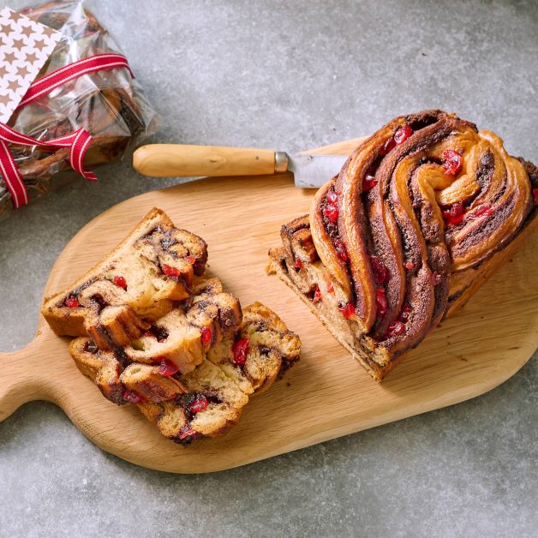
Ingredients:
- All-purpose flour, for dusting
- 2 (8 oz) pkgs Pillsbury ™ Crescent Roll Dough or crescent dough sheets
- 3 tbsp unsalted butter, plus more for greasing
- 3/4 cup chocolate-hazelnut spread
- 1/4 cup finely chopped Paradise ™ Candied Red Cherries
- 1/4 cup sugar

Directions:
Lightly dust a cutting board with the flour. Unroll 1 crescent roll dough onto floured board and pinch seams together as needed. Unroll second dough on top of first dough, pressing to stick together and pinching seams as needed. Press or roll dough into a 9x14-inch rectangle.
To a small microwave-safe bowl, add the butter and chocolate-hazelnut spread. Microwave in 30-sec. intervals, stirring between intervals, until warm and easy to spread. Spread chocolate mixture evenly over dough, leaving ½-inch border along one short side. Scatter the cherries over chocolate mixture. Starting from chocolate-covered short side, roll dough up into a tight log. Transfer dough to a parchment-lined plate and chill 20 min. Meanwhile, preheat oven to 350°F and grease a 9x5-inch loaf pan with butter. Line loaf pan with parchment.
Cut chilled dough log in half lengthwise and place cut-side up. Pinch tops of strips together and twist strips over each other, keeping cut-sides up. Place twisted dough in prepared pan. Bake 45 min., until cooked through and browned. If needed, cover with foil to prevent burning
Meanwhile, in a microwave-safe bowl, combine the sugar with ¼ cup water. Microwave 2–3 min., until sugar is dissolved. Set aside. When loaf comes out of oven, immediately brush loaf with syrup and let sit 30 min. before serving.

This recipe is featured in the December 2023 issue of Savory Magazine for Giant Food, Giant Food Stores, Martins Food, and Stop & Shop.

