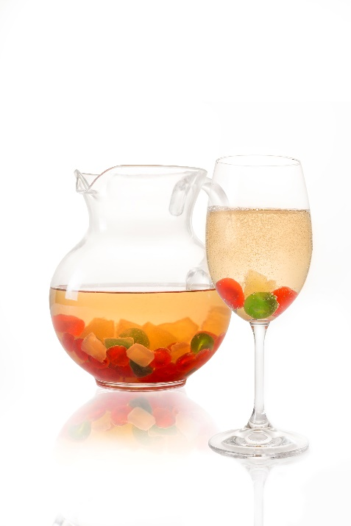

Candied Cheer

Ingredients for pitcher:
- 1 bottle, white wine, preferably Pinot Grigio or Riesling
- 1 container, Candied Cherry Pineapple Mix
- 1-2 splashes, Prosecco or other sparkling wine

Directions:
- Pour wine and Candied Cherry Pineapple Mix into a pitcher and let sit in a refrigerator for approximately 8 hours but no more than a day before serving

Serving:
- Pour wine and fruit mixture into a wine glass, making sure that cherry and pineapple pieces are plentiful
Add splash or two of Prosecco or other sparkling wine into glass before serving

