Chocolate Cherry
Cheesecake Brownies

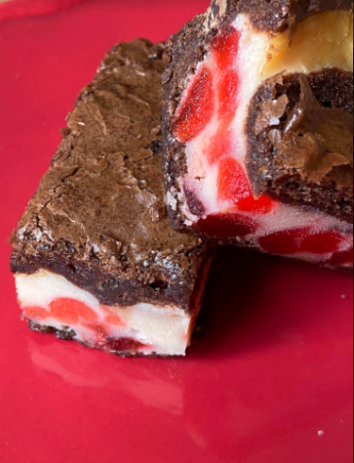
Ingredients:
- 1 box brownie mix
- water, oil, eggs needed
For the cheesecake layer:
- 1/2 cup sugar
- 1/2 tsp vanilla extract
- 8 oz cream cheese, room temperature
- 1 egg
- 3 tbsp flour
- 1 1/2 cups chopped glacé cherries

Directions:
To prepare cheesecake layer:
Cream together the sugar, vanilla and cream cheese.
Beat in the egg, then add the flour and mix until smooth. Fold in the glacé cherries and set the mixture aside.
Prepare brownie mix according to package directions.
Preheat oven to 350 degrees Lightly grease a 9 x 9-inch baking pan and line with parchment paper.
Pour about 1/2 or a little more of the brownie batter into the prepared pan.
Begin to carefully spoon the cheesecake mixture over the brownie batter, use an offset spatula to smooth it out.
Spoon the rest of the brownie batter on top of the cheesecake batter and smooth the top with an offset spatula or the back of the spoon.
Bake for 45-50 minutes or until the top is well crackled and dry looking and the brownies are starting to shrink back from the sides of the pan. Cool completely before cutting into cookie bars. Store in an airtight container.

A recipe of Lynn Huntley of https://www.turnips2tangerines.com/

