Vegan high protein
Tropical Banana Muffins

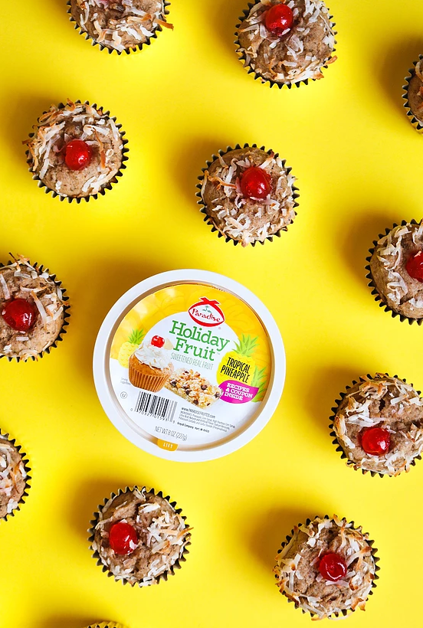
Ingredients:
- 2 ¼ cups whole wheat flour
- ¼ cup vanilla protein powder
- ½ tsp sea salt
- ½ tsp cinnamon
- 1 tsp ground ginger
- 2 tsp baking powder
- ½ tsp baking soda
- 1 ½ cups very ripe bananas, mashed
- ⅓ cup coconut oil, melted
- ½ cup unsweetened apple sauce
- 1 tsp vanilla extract
- 3 tbsp flaxseed meal
- 9 tbsp water
- ¼ cup brown sugar
- ¼ cup granulated sugar
- ¼ cup Paradise Fruit Tropical Pineapple finely chopped
- 1 tbsp chia seeds
- Sweetened coconut flakes for garnish
- Paradise Fruit Candied Red Cherries for garnish

Directions:
MAKE FLAX EGGS: In a small bowl, whisk together the flaxseed meal and water until well combined. Cover and refrigerate for 30 minutes to 1 hour to set up and thicken. Note: You can make these the night before and refrigerate overnight.
Preheat oven to 375°F. Line two 12-cup cupcake pans with 15 to 18 cupcake liners.
In a large bowl, sift together flour, protein powder, salt, baking powder, baking soda, ginger, and cinnamon. Set aside.
Melt the coconut oil in a small heat safe bowl in a microwave for 1 to 2 minutes. Set aside and allow to cool for 10 minutes.
In the bowl of a standing mixer, mash the bananas using a potato masher until smooth. Add the coconut oil, brown sugar, granulated sugar, flax eggs, and vanilla extract to the bananas. With the paddle attachment, mix until well combined.
Gradually add dry ingredients into banana mixture until well combined. Fold the candied pineapple and chia seeds in by hand using a spatula until evenly distributed.
Using a ¼-cup measuring cup, scoop and level the batter and fill each cupcake liner. It will yield about 15 to 18 muffins. In every unfilled space in the cupcake pan, carefully fill halfway with water.
Sprinkle the tops of each muffin with coconut flakes and place a cherry in the middle of each muffin.
Bake for 18 to 20 minutes, or until a toothpick inserted into the center of the muffins comes out clean. Let cool in the pan for 5 minutes before transferring muffins to a wire rack to cool completely. Store in an airtight container at room temperature for up to 3 days or freeze for up to a month.
Yields 15-18 muffins

A recipe from Adam Fisher of https://www.labeardedlady.com/

